Level 3 Residential Services (Supported Accommodation): Cost Benefit Analysis

A benefits analysis of the current Level 3 Residential Services (Supported Accommodation) sector in Queensland, and cost benefit analysis of introducing models of case management for residents.

A report for the Department of Families, Seniors, Disability Services and Child Safety.

Executive Summary
Level 3 Residential Services, or supported accommodation is a type of residential service which provides accommodation (bedroom with shared communal facilities), food and personal care services. While regulated by the Queensland Government, no direct funding is provided to supported accommodation operators.
Residents of supported accommodation often have complex circumstances, a history of trauma and limited decision-making ability, resulting in them being highly vulnerable and disadvantaged. 92.7 per cent of residents receive the Disability Support Pension and 73.2 per cent have multiple diagnoses, with up to 10 different conditions such as mental health/psychosocial issues, chronic health issues and intellectual impairments.
The number of supported accommodation facilities, and registered beds, has been declining over the past few years primarily due to lack of financial sustainability. Over the 18 months to April 2025, seven facilities accommodating 162 people closed (11 per cent decline). As at April 2025, there were 36 facilities providing 1,270 beds – since that time, this has now reduced to 34 facilities providing 1,237 beds.
Supported accommodation is providing a critical service to people who would often not be able to secure accommodation in the private rental market and is often the only accommodation option for people upon discharge from hospital, other health facility or correctional institution. If supported accommodation was not available, people would either not be able to be discharged (preventing the admission of new people into hospitals and health facilities) or would become homeless.
Reviews of supported accommodation have consistently called for the introduction of case management practices into facilities. Through better identification and understanding of the individual needs and goals of residents, case management can devise achievable plans to help meet these needs and goals, and enable clients to access the support and services they need.
Case management benefits accrue not only to the resident, but more broadly to government and the system, as well as service providers tasked with caring for the client.
Two models of case management have been analysed in this report:
- The first model, proposed by the supported accommodation peak, the Supported Accommodation Providers Association (SAPA), proposes 35 case managers and a $10,000 per resident subsidy to providers. At a cost of $15.9 million per year, it is estimated that benefits of $1.30 to $1.50 per dollar would accrue to government, residents and providers. There are challenges in this model for safety and sustainability which are explored further in the report.
- The second model, developed for this report, proposes a case manager and a number of support workers in each facility. At a higher cost of $28.3 million to $31.3 million per year, it is estimated that benefits of $1.31 to $1.44 per dollar would accrue to government, residents and providers. This model is considered to give residents better quality of life outcomes beyond those able to be quantified, and other benefits to workers such as improved safety.
Implementing both models would require changes to investment specifications, and investment in a new model of care for the supported accommodation sector including workforce capability building.
The report includes a summary of implementation actions and suggestions for investment specification changes and benefits measures.

Regardless of which model is pursued, it is clear that the whole supported accommodation sector, and most importantly its vulnerable residents, are at risk without any intervention. Without supported accommodation, many residents would likely be homeless and additional government-funded social and community housing would be needed to accommodate them. There are an estimated 150 employees across Queensland working directly with residents, in addition to employees of support services that would be impacted by the closure of the sector.
Funding the introduction of case management into supported accommodation will help retain the declining sector, improve service quality and the quality and safety of facilities, reduce costs to government and reduce rents for residents.

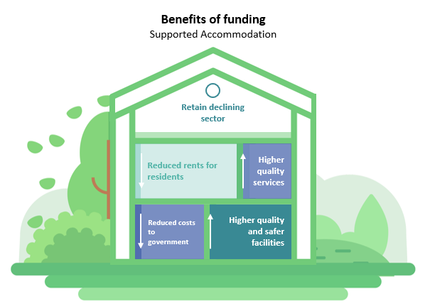

Level 3 Residential Services (Supported Accommodation)

Definition
Level 3 Residential Services make up one part of the overall accreditation process as a Residential Service operator. Level 1 is accommodation only which generally includes a furnished room and utilities, and Level 2 also includes food. Level 3 (also known as Supported Accommodation) provides accommodation (bedroom with shared communal facilities), food and personal care services.
Supported accommodation is regulated under the Queensland Government’s Residential Services (Accreditation) Act 2002. A personal care services is defined in the Act as:
personal care service means a service of regularly providing a resident with—
- help in—
- bathing, toileting or another activity related to personal hygiene; or
- dressing or undressing; or
- consuming a meal; or
- meeting a mobility problem of the resident; or
- taking medication; or
- help in managing the resident’s financial affairs.

Residents of Supported Accommodation
Residents of supported accommodation services often have “complex support needs, many of whom have an intellectual disability, acquired brain injury, mental health concerns, or issues with drug and alcohol use. Many level 3 residential service residents have some degree of impaired decision-making ability, and often the decision-making ability of the person, and whether or not they have a decision-maker appointed for particular decisions, will not be known or recognised by the service provider.” ('Safe, secure and affordable'? The need for an inquiry into supported accommodation in Queensland, August 2023. The Public Advocate.)
The evaluation of the SAPA Resident Needs Screening Tool found the key demographics of residents to be:
- 76 per cent over the age of 45 years
- 70.1 per cent male
- 92.7 per cent receive the Disability Support Pension (DSP)
- 73.2 per cent have multiple diagnoses, with up to 10 different conditions. The most common diagnoses include:
  - mental health/psychosocial issues (85 per cent)
  - chronic health issues (46.8 per cent)
  - intellectual impairments (27.5 per cent).
The evaluation also found that over 35 per cent of residents are referred to supported accommodation from a mainstream service (hospital 21 per cent, mental health 10.9 per cent and corrective services 3.6 per cent). Other referral pathways included family and friends (16.7 per cent), other supported accommodation providers (13.6 per cent), and National Disability Insurance Scheme (NDIS) Support Coordinators (12 pe cent). Nearly 30 per cent of residents’ previous housing situation would be considered as temporary.

“People who enter level 3 residential services are often identified as those who have ‘fallen through the gaps’ in other systems.” Public Advocate Report, 2023

Operators of Supported Accommodation
Supported accommodation is not funded by the Queensland Government. The majority of providers are privately owned companies and are committed to providing a safe, high-quality home for residents.
Providers charge residents rent and a fee to cover the accommodation, food and personal care services. The total charge is set at up to 85 per cent of the resident’s income (usually DSP) plus 100 per cent of Commonwealth Rent Assistance. Some operators may charge lower rents, with some charging as low as 60 per cent of total income.
The staff of supported accommodation providers are mostly not qualified in social work. In some cases, a person employed as a cook would be supporting residents with medication management or attempting to de-escalate behaviours. There are an estimated 150 employees working for the supported accommodation operators, plus additional people working in associated services such as the NDIS businesses.
Providers are represented by the peak body Supported Accommodation Providers Association (SAPA). In representations to government and in the conduct of this report, SAPA has stated that individual providers face annual deficits with charges not covering the costs of services, rents, maintenance and repairs. Some operators have started NDIS businesses to subsidise their supported accommodation operations.
Providers are also concerned about the support they can viably provide their residents to ensure they have a high level of safety, health and wellbeing.
Operators are also subject to other regulatory conditions such as building conditions, fire management and food safety.

Snapshot of the Supported Accommodation Sector
According to the Public Register of Residential Services, as at April 2025 there were 36 supported accommodation services accommodating 1,301 people. Since October 2023 (18 months), six services were closed reducing the total number of people that could be accommodated by 162 (11 per cent decrease).
Since the April 2025 register update another two services accommodating up to 64 residents has also closed. Other providers have indicated they may also close.
Nearly half of current services (and available beds) are located in the Brisbane City Council area, with the remaining located across South East Queensland (except two located in Townsville).
Supported accommodation represents about 17 per cent of the total number of people accommodated in a residential service (Levels 1, 2 and 3 combined).
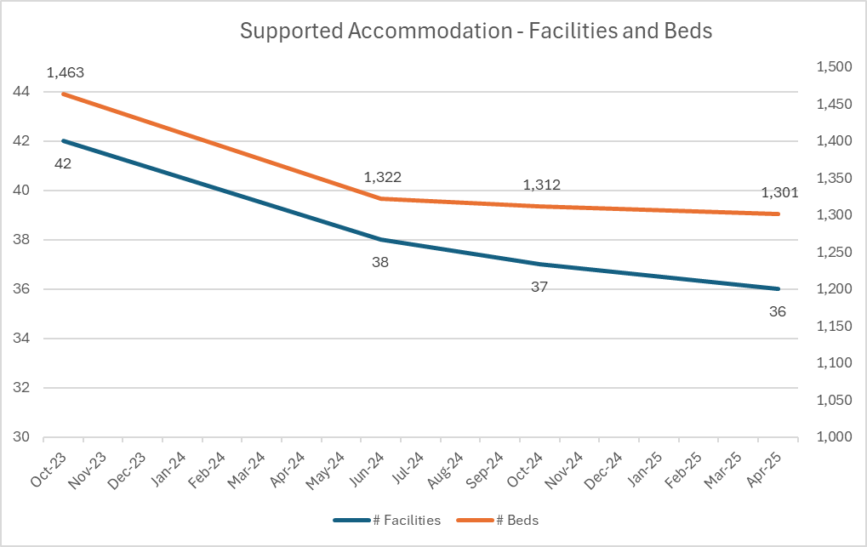

Analysing Supported Accommodation

Key Benefits of Supported Accommodation
Supported accommodation is providing a critical service to people who would often not be able to secure accommodation in the private rental market. Many residents would also find it difficult to maintain their own home in social or community housing.
Supported accommodation is often the only accommodation option for people upon discharge from hospital or other health facility (including mental health and alcohol and other drug (AOD) services) or correctional institution. If supported accommodation was not available, people would either not be able to be discharged (preventing the admission of new people into hospitals and health facilities) or would become homeless.

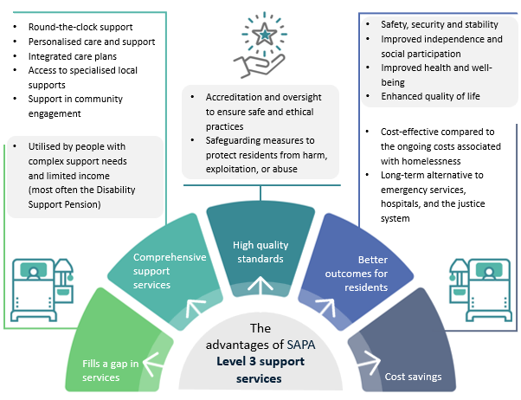

Supported accommodation providers help manage medical and health issues, including the management of medications and organising health service to visit residents at the facility. Most providers have regular arrangements with GPs, podiatrists and other allied health professionals to visit facilities. External providers also schedule blood testing at facilities.
Other services benefit from simpler, centralised access to their clients, such as the Public Guardian and Public Trustee, and NDIS supports coordinators.
Supported accommodation providers help enable successful support of residents, including through visiting services and organising of outside appointments, supporting residents to manage their emotions, anxieties and behaviours, assisting with money management (in conjunction with the Public Trustee or financial guardian) and by establishing and instilling routines for residents. These routines also enable more effective service visits from NDIS and aged care providers.
Another key benefit of supported accommodation is that it provides a longer-term accommodation option for residents. Consistent with the successful Housing First approach, residents are not forced to leave after a particular length of time or when goals are achieved.

Key Challenges of Supported Accommodation
The key challenges for supported accommodation relate to the successful management of a vulnerable and complex cohort of residents. This is in addition to the ongoing viability of the supported accommodation model (see summary in ‘Operators of Supported Accommodation’ above).
As expected with people who have a history of trauma, a range of mental health, psychosocial and chronic health issues and intellectual impairment, it is difficult to support them within a facility without regular, specialised services. In addition, many residents have encountered abuse by the systems that are supposed to care for them and have become untrusting of government and organisations.
The Public Advocate’s 2023 ‘Safe, secure and affordable’ report noted “stakeholders suggested that more specialised services are required to better meet the complex needs of many of the current residents of supported accommodation. This could include, for example, specific services to address the needs of people with disability, or people who require aged care or mental health services, or people exiting the prison system.”
Upon entering a facility, it is difficult to understand the resident’s full scope of needs and issues – and with limited services, these needs and issues take a long time to become understood. Without this understanding, it is extremely difficult to prevent escalation of behaviours and decline in health and wellbeing.
The results of the SAPA Resident Needs Screening Tool found that there are significant unmet needs for residents of supported accommodation. There are significant gaps in daily living assistance and health and wellbeing support.
As well as managing existing issues, a resident will experience new issues throughout their life which also need to be managed, such as wound management and post-operative/hospital care.
Medication management is the highest risk activity of supported accommodation and presents the greatest challenge. The various health systems place responsibility for medication management on the provider, but this is also the most difficult issue to manage, especially for dysregulated residents or residents with low levels of trust with other people.
Within the current environment, providers face challenges in assisting residents to attend appointments, participate in community activities and do their own shopping. There is no capacity for providers to help residents apply for external supports via the NDIS and My Aged Care. The inability to attend appointments mean that residents are not undertaking important activities such as preventative health and dental care.
While some residents have funded NDIS and Aged Care packages, these services are only provided at set times and for a limited number of instances per week. For residents with needs beyond that offered by these systems, it falls back on the supported accommodation provider to assume this responsibility.
These pressures and the complexity of residents also mean that the level of personal care expected to be provided in supported accommodation will not meet all the needs of many of the residents, particularly those who with complex needs (disability, mental health challenges, or alcohol and other drug misuse).
The various and cumulative challenges for supported accommodation providers mean that workers can only react to crises – there is no capacity to proactively manage residents and coordinate services. These crises also result in a government-funded crisis or emergency response, including police, ambulance and mental health acute care teams. Residents also often self-admit to emergency departments.

Resident Incidents
Supported accommodation providers report high number of incidents within their facilities, mostly relating to dysregulated behaviours. It should be noted, however, that accommodation models that have consistent, qualified support workers on site record much lower incident rates.
Across the sector, it is reported that 52.7 per cent of residents experienced at least one incident report – and the average resident experiences up to 20 incidents per year. Within just a four-week period, 24.5 per cent of residents had an emergency/crisis contact – the average number of emergency/crisis contacts was 6.1 per person involving 2.4 emergency/crisis services.

“This highlights an urgent need for implementing proactive and integrated support strategies for preventative care to decrease the cycle of dependency of ER/crisis interventions.” SAPA Resident Needs Screening Tool Final Report
Limited data collected directly from providers consulted on this project show high levels of incidents amongst residents.
Facility | Support Level | Resident Vulnerability | Incidents Per  Year (approx.) | Seriousness
1 | Low-moderate  (staff on site, not qualified) | Medium-High  (avg. 35 residents) | 850  [24 per resident] | High = 5%  Medium = 9%
2 | Low-moderate  (staff on site, some qualified) | Very High  (avg. 70 residents) | 1,300  [18 per resident] | High = 10%  Medium = 25%

This data is contrasted against a provider who employs qualified support workers (Certificate III or support worker experienced) with an all-day presence at the facility. Despite also having highly vulnerable residents, the provider experiences small numbers of incidents beyond what would be considered ‘low’ seriousness (note that these are anecdotal, and data is not formally collected). Any presentations for Emergency Department or ambulance callouts are the result of the health of the resident, not behavioural issues. The provider attributes this success to staff understanding the resident and recognising triggers that may result in dysregulated behaviour.
While eviction data is not available across the whole sector, limited data from three facilities accommodating approximately 200 residents shows 19 evictions over 11 months (eviction rate of over 10 per cent per year). The most common reason for eviction is due to behavioural issues.

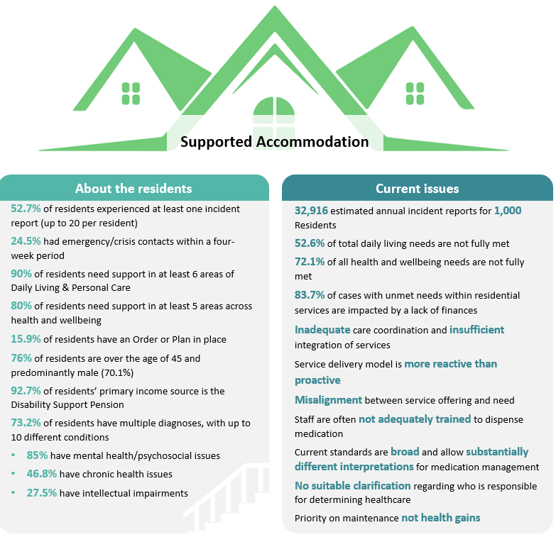

Case Management in Supported Accommodation
As detailed above, residents of supported accommodation are extremely vulnerable and face many challenges on a day-to-day basis. Consistent with community services practice, and seen in supportive housing programs, applying a case management approach can help meet the complex needs of residents, assist successful tenancy sustainment and contribute to improved health, wellbeing and quality of life.

Recommendations from Inquiry into the provision and regulation of supported accommodation in Queensland Report No. 44, Community Support and Services Committee June 2024
The Inquiry made recommendations related to the introduction of case management (Rec 8b), or where effective case management would help meet the recommendation (Recs 6 and 8a):
Recommendation 6: The committee recommends the Department of Housing, Local Government, Planning and Public Works consider how it can better support vulnerable tenants living in residential services, including:
- tenants issued with a Notice to Leave without sufficient notice, following an alleged breach
- modification of zero tolerance requisites in tenancy agreements with vulnerable residents.
Recommendation 8a: Endorsing the Public Advocate’s Recommendation 2, the committee recommends the Department of Housing, Local Government, Planning and Public Works require providers of accredited level 3 residential services to arrange for individual independent assessments of the housing and support needs of all new residents, and bi-annual assessments of the housing and support needs of existing residents.
Recommendation 8b: Endorsing the Public Advocate’s Recommendation 3, the committee recommends that the Queensland Government should consider funding and oversight of the provision of case management services to supported accommodation residents who currently have significant unmet support needs.

Recommendation from Royal Commission into Violence, Abuse, Neglect and Exploitation of People with Disability
The Royal Commission made a recommendation about supported accommodation delivered by state and territory governments. Effective case management would help deliver on this recommendation.
Recommendation 7.38 Minimum service standards and monitoring and oversight of supported residential services and their equivalents
Minimum standards should require all SRS providers and their equivalents in other jurisdictions to:
- develop support plans for each resident, covering personal care, financial management, medication management, and the use of restrictive practices
- keep up-to-date records of how services are delivered in line with support plans, to allow regulatory bodies to more effectively monitor the quality of supports and services by regulatory bodies
- establish clear complaint management processes, including how complaints are reported to the central registration body, and a feedback loop for residents, their family and advocates
- guarantee access to independent advocacy services through advocacy organisations and community visitor schemes
- support residents to access independent advocacy services focused on identifying alternative, longer term accommodation options in recognition of the transitionary nature of these services.
For supported accommodation, case management would involve a holistic approach where case managers would work with residents with complex goals requiring a co-ordinated response across more than one service provider. The case manager would work with all residents to form a case/support plan identifying the resident’s needs and goals, and actions that will help meet them. The case manager and resident would regularly review the plans to monitor progress and identify new needs or goals.
Any actions arising from the plan would be provided by the case manager, another staff member of the facility, a visiting service or via an external off-site provider. Case managers are experienced in forming service provider networks and leading case coordination to enable residents to access needed services.
Activities to meet the resident’s support plan would typically include daily living support, tenancy management support, financial advice and advocacy, legal and justice support, emotional counselling, health, mental health and AOD, accessing NDIS and Aged Care, community connection and recreational and social opportunities, through to longer term exit planning into public or private rental (if the resident chooses). Experienced case managers are also able to support people to make their own decisions about the services they receive and the choices they make.
Case managers will also be able to guide and advise other facility staff with how to best support residents, such as building trust and rapport, effective de-escalation techniques and advocating for services.

The report ‘Evidence about Best Practice in Supported Accommodation Services: What Needs to be in Place? A literature review for the NDIS Quality and Safeguards Commission Professor Christine Bigby October 2022’ provides ten components of a best practice framework for supported accommodation.
The following seven components are applicable for case management practice.
- Staff practice of Active Support
- Staff practice that supports healthy lifestyles and access to health care
- Staff practice with families
- Gaining the perspectives of people who live in group homes
- Staff practice enabled by Frontline Practice Leadership
- Managerial practices that support access to specialist interventions and other forms of additional support.
- Managerial practices that support staff collaboration, service coordination, involvement in planning and support for decision making.

Benefits of Case Management
The benefits of case management for vulnerable people is well documented. Case managers better identify and (through improved engagement techniques and knowledge of vulnerable people), can devise achievable plans to help meet identified needs and goals, and enable clients to access the support and services they need.
Benefits accrue not only to the client, but more broadly to government and the system, as well as service providers tasked with caring for the client.
Importantly, case management will improve the quality of life for residents.

For supported accommodation, key benefits include:
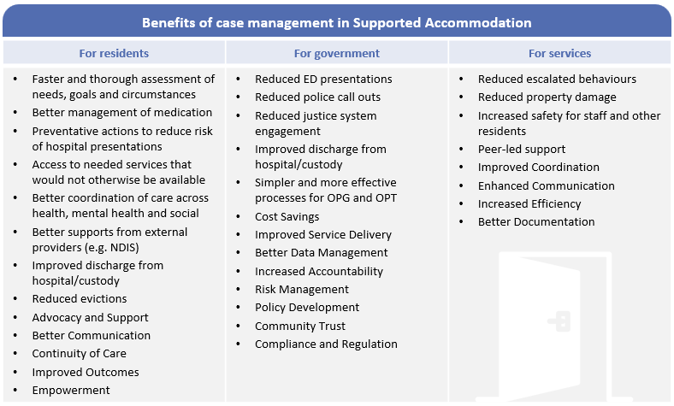

Case managers will assist with effective transition of residents into and out of supported accommodation. Improvements at inward transition mean that potential residents can be safely discharged from health facilities earlier, and less likely to experience escalated behaviours early in their residence. Case managers can build the skills and confidence of residents to move into independent housing if they choose, and provide post-transition support where needed to prevent re-entry to transitional housing or homelessness.
Residents will be able to be supported to apply for NDIS (only 68 per cent of residents have NDIS funding despite 92 per cent receiving a DSP) and My Aged Care and access a wider range of free and accessible services, from specialist health and wellbeing through to social, recreational and educational activities. Importantly, residents can be supported to access preventative health and dental services.
Where a resident’s situation can be stabilised and routines established, they may be able to pursue supported employment opportunities – increasing their wellbeing and increasing their income.
For supported accommodation providers, they will be able to increase the density of their facilities with reduced behavioual and other resident issues. Many faciliites do not run at 100 per cent capacity due to increased risk of incidents.

Costs of Case Management – Two Proposed Models
SAPA has proposed a model to introduce case management tied to a standard per-resident subsidy. Referred to as the SAPA Case Manager and Viability Subsidy Model it will bring a limited case management model and also help to support the viability of facilities and stem the flow of closures.
A second model is presented focused on supporting residents with an intensive case management model. Referred to as the Case Manager and Support Workers Model it incorporates a mix of case managers and qualified support workers and while not having a viability focus it will help improve viability of the sector.
Due to the size of the facilities, resources from the second model could be shared across some facilities. For the purposes of the costings in this report, it is assumed that the 34 remaining facilities would be considered as a total of 29 facilities. See proposed groupings at Appendix 1.

Model | Case Manager and Viability Subsidy | Case Manager and Support Workers
Staffing | Case Managers (various) | - One x Case Manager (Social, Community, Home Care and Disability Services (SCHADS) 5).  - Two shifts of two x Support Workers (SCHADS 2/3).  - One sleepover shift of one x Support Worker (SCHADS 2/3).  Model 2a: additional daytime support workers for larger facilities.
Caseload | Average 35 residents  (range from 15 to 40 depending on site) | - Case Manager: focus only on high intensity and provide overarching supervision.  - Support Workers – Day: 15 to 20 residents.  - Support Workers – overnight: up to 75 residents (depending on site).
Total Funded FTE | 35  (plus additional depending on how operator allocates subsidy) | 145 (note 116 FTE over 2 shifts = 58 FTE per shift)  Model 2a = 162
Other | $10,000 subsidy per resident | N/A
Total Cost | $13.8M p.a. | $28.3M p.a.  Model 2a = $31.3M p.a.
For support workers, costings are based on each shift comprising one SCHADS 2 and one SCHADS 3 support worker. The sleepover shift would be a SCHADS 2 level support worker.
- SAPA Case Manager and Viability Subsidy Model
As proposed by SAPA, the Case Manager and Viability Subsidy Model includes:
- A total of 35 case managers across Queensland.
- $10,000 per resident subsidy paid directly to providers. A single facility will not receive more than $500,000 per year (there are ten facilities with more than 50 residents).
The total cost of this model would be estimated at $13.8 million per year.
The benefits and challenges specific to the Case Manager and Viability Subsidy Model include:
 | Benefits | Challenges
Case Managers | Case managers will be able to be deployed flexibly as required across the facilities. | Staff working with vulnerable people should mostly work in pairs for safety and peer support. This model does not allow for working in pairs.  Costings of $3.5M for 35 case managers is under-budgeted and will require use of some of the viability subsidy or self-funded.
Viability Subsidy | Gives operators flexibility to allocate funding to highest identified need for their facility and residents. | Reduced ability of government to focus resources to government priorities.
Overall | Cheapest model.  Identified by SAPA as most effective method of supporting the sector | Less intensive approach and will not maximise benefits of a case management model.

As noted in the Challenges above, $3.5M p.a. is not considered sufficient to cover the costs of employing 35 case managers. It is estimated that fully costed case managers would be approximately $5.6 million p.a. (total measure = $15.9 million).

- Case Manager and Support Workers Model
The Case Manager and Support Workers Model includes the following staff per site (or collection of sites):
- one case manager [SCHADS 5]
- two daytime support workers (16 hours per day, i.e. two shifts) [one x SCHADS 2 + one x SCHADS 3 per shift]
- one overnight support worker (sleepover conditions) [SCHADS 2].
The model includes case managers who are highly qualified workers with degree level qualifications and paid generally at the SCHADS 5 level or above. However, this model also includes lower-level support workers who would enable the delivery of more intensive support for residents, and therefore improved outcomes for residents.
Based on best practice individual support, a case manager can take the overall management of ‘cases’ (support planning and review, network/partnership development and systems advocacy) and provide supervision to other staff. A support worker with a Certificate III qualification at a SCHADS 2/3 level would be able to provide personalised supports needed by residents under the guidance of a case manager – this support combined will deliver more intensive and effective support.
It is recommended that the support workers are employed directly by the accommodation provider. This will enable closer relationships between workers and residents, enable better building of trust and rapport, on-site staff management, and support viability within facilities.
The total cost of this model would be estimated at $28.3 million per year.
Variations: Model 2A
Given the size of some facilities, an alternative option would be to increase the number of support workers during the day for larger facilities – see column ‘Model 2a’ in Appendix 1 for facilities with additional support workers. Under this model an additional 17 support workers would be funded across Queensland. The additional support workers would be paid at the SCHADS 2 level.
The total cost of this model would be estimated at $31.3 million per year.
The benefits and challenges specific to the Case Manager and Support Workers Model include:
 | Benefits | Challenges
Case Managers | Case managers will be allocated to specific facilities enabling trust building with residents and clear management of support workers. | Reduced flexibility as a sector (across all facilities).
Support Workers | More intensive, professionalised support of residents.  Providers will be able to allocate funds currently used for support and other workers to other priorities. | Requires significant expansion of supported accommodation workforce. Likely will require expansion of management structures.
Overall | Most intensive approach that maximises benefits of a case management model.  Whilst not SAPA proposed model, it is still supported by providers.  Will allow operators to reduce rents charged to residents. | More expensive model.

Alternative Funding Options – Victorian Government Model
The Victoria Government funds the Supported Residential Services Outreach and Assistance Program (SRS-OAP). SRS-OAP funds health and wellbeing supports for residents of supported accommodation and funds accommodation providers to help maintain supply and ensure facilities are safe and amenable.
Details of funding arrangements for this program are not publicly available. Further information on this program is at Appendix 2.

Benefits of Funding Case Management and Supports in Supported Accommodation
As described above, implementing case management to supported accommodation via the two models outlined will accrue benefits to residents, supported accommodation providers, and the community and government.

Benefit – Prevention of Homelessness
The key measurable benefit that can be quantified is the ability of supported accommodation to prevent homelessness amongst many of its residents – without supported accommodation, it is more than likely that the resident would be homeless. The report Ending Homelessness Through Permanent Supportive Housing: A Cost Offset Update estimates that “people who were chronically homeless in Brisbane would use Queensland Government services that cost approximately $64,273.26 annually”.
For the benefit analysis, it is assumed that supported accommodation prevents homeless for 54 per cent of all residents – i.e. those who are at imminent risk of homelessness. This has been calculated based on the SAPA Resident Needs Report data for the following referral points: lack of suitable housing (36.9 per cent); institutional exit (11.3 per cent); tenancy at risk (5.4 per cent); and financial issues (0.4 per cent).
Given supported accommodation residents would still be above average users of emergency services and hospitals, not all costs of homelessness would be avoided. For each model, it is assumed that the more intensive the case management, the higher the savings achieved.
Based on the above assumptions and the current cohort of 1,237 residents, the calculable benefits of each model would be:
Model | Case Manager and Viability Subsidy | Case Manager and Support Workers | Case Manager and Additional Support Workers
Residents | 1,237 | 1,237 | 1,237
Imminent Risk of Homelessness | 54 per cent | 54 per cent | 54 per cent
Cost of homelessness (per resident) | $64,273 | $64,273 | $64,273
Anticipated Cost Savings | 40 per cent | 70 per cent | 80 pe cent
Annual Benefits | $17.17M | $30.05M | $34.35M

Benefits for Residents
With funded case management, providers have stated that they will be able to reduce rents for residents. This would result in more disposable income and increased choices for residents.
Level 2 rents are commonly 15 to 25 per cent cheaper than Level 3. For a resident on a DSP this would be a saving of $170 to $280 per person (or $5.7 million to $9.5 million per year across the sector). Savings would be higher for Model 2 due to the higher income going to providers.
Unless on a pension (DSP or Age Pension) or employed, supported accommodation would not be affordable for an individual. On a Level 2 rent, people on non-pension benefits (e.g. Newstart Allowance) may be able to afford supported accommodation.

Benefits for Providers
For supported accommodation providers, the funding of case managers and support workers would reduce the costs related to damage. Limited data shows outstanding repair costs of $1,000 per resident – applying an average repair cost of $1,000 per resident for the total cohort would be $1.237 million per year.
Case managers will support residents to receive services under the NDIS and My Aged Care. This will take pressure off the supports provided by providers and allow increased services and provision of activities for all residents.

Benefits for Government/Community
A separate measure (which would be included in the homelessness estimate) is a reduction in emergency/crisis services for supported accommodation residents.
The Independent Health and Aged Care Pricing Authority estimates that a presentation to a Queensland Emergency Department cost on average $663 per instance. According to the evaluation of the SAPA Resident Needs Screening Tool, there are over 3,000 emergency department presentations every year. Emergency Department presentations for supported accommodation residents would total an estimated $2.0 million per year. Under a case management model where health conditions would be better managed and behaviours would not escalate, it would be expected that presentations would be reduced by 40 to 70 per cent depending on the intensity of case management – resulting in emergency department savings of $0.8 million to $1.3 million per year.
Using data from the Report on Government Services 2025, the average cost of an ambulance callout in Queensland is $994 per instance. According to the evaluation of the SAPA Resident Needs Screening Tool, there are nearly 2,500 ambulance callouts to a supported accommodation facility every year. Ambulance callouts for supported accommodation would total and estimated $2.5 million per year. Under a case management model where resident crises would be better managed, it would be expected that callouts would be reduced by 60 per cent - resulting in ambulance callout savings of $0.9 million to $1.7 million per year.

Summary of Benefits for Each Model
Model | Case Manager and Viability Subsidy | Case Manager and Support Workers | Case Manager and Additional Support Workers
Homelessness Prevention | $17.17M | $30.05M | $34.35M
Reduced Rents for Residents | Up to $5.7M | $5.7M to $9.5M | $5.7M to $9.5M
Reduced Damage Costs for Providers | Up to $1.237M | $1.237M | $1.237M
Annual Cost of Funding | $13.8M  [$15.9M] | $28.3M | $31.3M
Estimated CBA | 1.3 to 1.5 | 1.31 | 1.44

Implementation and Measurement of Case Management for Supported Accommodation

Implementation
It is recommended that case management and support worker funding would be provided under the Individuals Investment Specification.
- Service Users: The needs of residents would be sufficiently covered by the ‘Service delivery requirements for all services’. However, specific requirement would be simple to develop and be similar to the requirements for ‘Adults affected by alcohol (U1020)’ and ‘Adults experiencing personal, family, relationship and/or financial issues (U1150)’.
- Service types: The needs of residents would be supported through:
  - Access – Community support (T101)
  - Access – Information, advice and referral (T103)
  - Support – Case management (T314)
  - Support – Counselling (T318).
Relevant outcomes from the Individuals Investment Specification would include:
- service user needs are identified and they are connected to appropriate services and information;
- improved service user’s sense of healing, justice and personal wellbeing;
- reduced risk of being taken into police custody or statutory services for public intoxication offences;
- improved cultural identity and connectedness.
To meet the requirements of the investment specification, providers would need to be accredited to Human Services Quality Standards. This would include paying for an external audit every 18 months.
In meeting the Standards and to commence delivering effective services, providers would need to be supported through a process of capacity building – for both the organisation and for its staff. Given the vulnerability of residents, it is recommended that staff are at a minimum receive additional training in trauma-informed practice and diversity awareness.
Funded staff will need to meet qualification requirements – ranging from a Certificate III or IV (support workers) to a three-year bachelor’s degree (case manager).
To best support and supervise, a supported accommodation practice framework will need to be developed. Given the complexity of the role of case managers and the vulnerabilities of residents, a framework is needed which can support case managers, implement clear and robust practice and ensure professional supervision.
SAPA is developing a Model of Care, under the guidance of a Practice Leader which would support best practice case management and support.

Measuring benefits
The benefits arising from introducing case management would need to be measured against a baseline prior to funding commencing (some providers already have some relevant measures for baselining). The benefits of case management would also be likely to increase over time as the case managers and support workers build trust and rapport with residents, and as practices are embedded and improved.
Benefit | Measure
Improved resident health | - Improved health (to be defined for each resident).  - Improved mental health (to be defined for each resident).  - Increased rates of vaccination and anti-viral use.  - Reduced problematic alcohol and other drug use.
Improved resident wellbeing | - Increased satisfaction with facility.  - Increased social and economic participation.  - Improved quality of life.  - Increased access and use of external support services.  - Increased number of residents receiving NDIS and Aged Care services.
Improved resident safety | - Reduced incidents, including:  - medication and residents missing medication  - behavioural  - property damage.
Improved resident housing stability | - Reduced rate of evictions.  - Increased rate of residents exiting to stable housing.
Reduced emergency/crisis responses | - Reduced ambulance callouts.  - Reduced police callouts.  - Reduced presentations to emergency departments.  - Reduce acute mental health care team callouts.
Improved staff skills and wellbeing | - Increased confidence in working with vulnerable residents.  - Reduced incidents impacting staff.  - Increased retention rates of staff.
Improved viability of sector | - Increased number of beds available.  - Reduced rate of facility closures.

Appendix 1 – Proposed Grouping of Facilities for Model 2 and Model 2a

Ref Number | Street Address | Residents (Max) | Model 2:  Case Manager + Support Workers | Model 2a:  Additional Support Workers
RS00000005 | 52 CHALK ST, WOOLOOWIN, 4030 | 30 | 1 x CM, 2 x SW | -
RS00000011 | DIAMOND LODGE AND DIAMOND HOUSE | 55 | 1 x CM, 2 x SW | + 1xSW (Day)
RS00000013 | TARAMPA LODGE | 64 | 1 x CM, 2 x SW | + 1xSW (Day)
RS00000015 | CLAYFIELD HOUSE | 75 | 1 x CM, 2 x SW | + 2xSW (Day)
RS00000016 | COTLEW MANOR | 62 | 1 x CM, 2 x SW | + 1xSW (Day)
RS00000019 | THOMAS HENRY HOUSE | 29 | 1 x CM, 2 x SW
RS00000021 | FERNVALE AFTER CARE CENTRE | 30 | 1 x CM, 2 x SW
RS00000027 | COORPAROO SUPPORTED LIFESTYLE | 24 | 1 x CM, 2 x SW
RS00000036 | MURRAY LODGE SUPPORTED ACCOMMODATION | 49 | 1 x CM, 2 x SW | + 1xSW (Day)
RS00000038 | GRACEMERE LADIES HOME | 28 | 1 x CM, 2 x SW
RS00000058 | BERGIN GARDENS & GILBERT LODGE; 9A & 9B SALISBURY RD, IPSWICH | 23 | 1 x CM, 2 x SW
RS00000059 | CHRISTINE COURT | 45 | 1 x CM, 2 x SW | + 1xSW (Day)
RS00000063 | 141 GEDDES ST, EAST TOOWOOMBA | 11 | 1 x CM, 2 x SW
RS00000072 | 10 MORRIS ST, WEST END | 21 | 1 x CM, 2 x SW
RS00000073 | HERSTON LODGE | 75 | 1 x CM, 2 x SW | + 2xSW (Day)
RS00000104 | 43 & 45 MERLOO DR, NERANG | 19 | 1 x CM, 2 x SW
RS00000155 | AUSCARE HOUSE | 35 | 1 x CM, 2 x SW
RS00000206 | MONTRAY VILLA HOSTEL | 52 | 1 x CM, 2 x SW | + 1xSW (Day)
RS00000208 | LILLIPUT CARING | 60 | 1 x CM, 2 x SW | + 1xSW (Day)
RS00000210 | ELIZABETH JANE GARDENS | 17 | 1 x CM, 2 x SW
RS00000235 | 157-159 OLD LOGAN VILLAGE RD, WATERFORD | 24 | 1 x CM, 2 x SW
RS00000295 | ROBINA LODGE | 42 | 1 x CM, 2 x SW | + 1xSW (Day)
RS00000315 | COCKATOO LODGE | 22 | 1 x CM, 2 x SW
RS00000329 | GREENSLOPES HOUSE | 75 | 1 x CM, 2 x SW | + 2xSW (Day)
RS00013365 | AVALON LODGE | 136 | 1 x CM, 2 x SW | + 2xSW (Day)
RS00013532 | ALORA RETREAT MORNINGSIDE | 25 | 1 x CM, 2 x SW
RS00013554 | CALOUNDRA HOUSE | 53 | 1 x CM, 2 x SW | + 1xSW (Day)
RS00000225 | 9 LORIMER ST, SPRINGWOOD, | 12 | 1 x CM, 2 x SW
RS00014190 | 10 LORIMER ST, SPRINGWOOD, | 12 | 1 x CM, 2 x SW
RS00000325 | 360 RICHMOND RD, CANNON HILL | 6 | 1 x CM, 2 x SW | + 1xSW (Day)
RS00000330 | 356 & 358 RICHMOND RD, CANNON HILL | 8 | 1 x CM, 2 x SW | + 1xSW (Day)
RS00014223 | 362 RICHMOND RD, CANNON HILL | 6 | 1 x CM, 2 x SW | + 1xSW (Day)
RS00014224 | 364 RICHMOND RD, CANNON HILL | 6 | 1 x CM, 2 x SW | + 1xSW (Day)
RS00014225 | 366 RICHMOND RD, CANNON HILL | 6 | 1 x CM, 2 x SW | + 1xSW (Day)

Appendix 2 – Victorian Government Supported Residential Services Outreach and Assistance Program
The Supported Residential Services Outreach and Assistance Program (SRS-OAP) supports the health and wellbeing of people living in Supported Residential Services and helps maintain a supply of low-cost accommodation for low-income Victorians who need assistance with the activities of daily living.
SRS-OAP provides three lines of Support Funding designed to support resident-focused improvements in supported residential services:
- Facility Cost Relief - a financial supplement to support providers maintain a supply of low-cost beds.
- Amenity and Safety funding – to support physical amenity and safety improvements in facilities, increase provider staff training, and resident activities.
- Fresh Food funding – to support the availability and access to fresh food for residents of supported residential services.
External funded organisations are funded to provide Capacity Building and Resident Outreach services to participating residential services. This funding provides for skilled health and community workers to be available on site and develop positive working relationships with providers and staff to assist residents with their support needs, access local services and participate in the community The external organisation coordinated collaborative case planning and has access to flexible funds/brokerage to assist residents. A key role of the external workers is to increase the capability of the staff working in the facilities.

